ANNOUNCEMENT:
2023 NMA Peach Council Essay Writing Contest

The National Management Association (NMA) would like to invite three (3) students from the 7th or 8th grade in your school or home school program to participate in our essay writing contest. The contest’s purpose is to help the students to build their skills in communication. They will be competing with other schools from across our southeast regional area represented by the Peach Council of NMA.

The topic of the Essay Contest is
“What are the traits or characteristics of a good student leader in high school?”

Each contestant is required to research, compose, and submit their own essay with proper adult consent and school program approval by April 3, 2023 to our contest director. The top three students in our southeast region will receive awards of $75, $50, and $25 respectively. If any of your students win one of the of top 3 prizes, we can present that prize at your award day ceremonies, if desired. All other contestants will receive a certificate of participation.

Please review the enclosed rules, registration forms, and other contest materials. Promotional flyers have also been included to help advertise the contest. We can e-mail any of these documents for your school’s website.

We look forward to seeing your entries. The contest is free and open to the invited schools or home school programs through our local members and / or chapters.

Best regards,
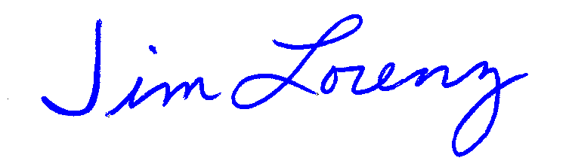
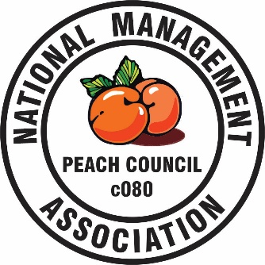
Jim Lorenz
Essay Contest Director
Peach Council
National Management Association
1 Canterbury Lane
Bluffton, SC 29910
843-290-6459 (C)
jblorenz52@gmail.com

